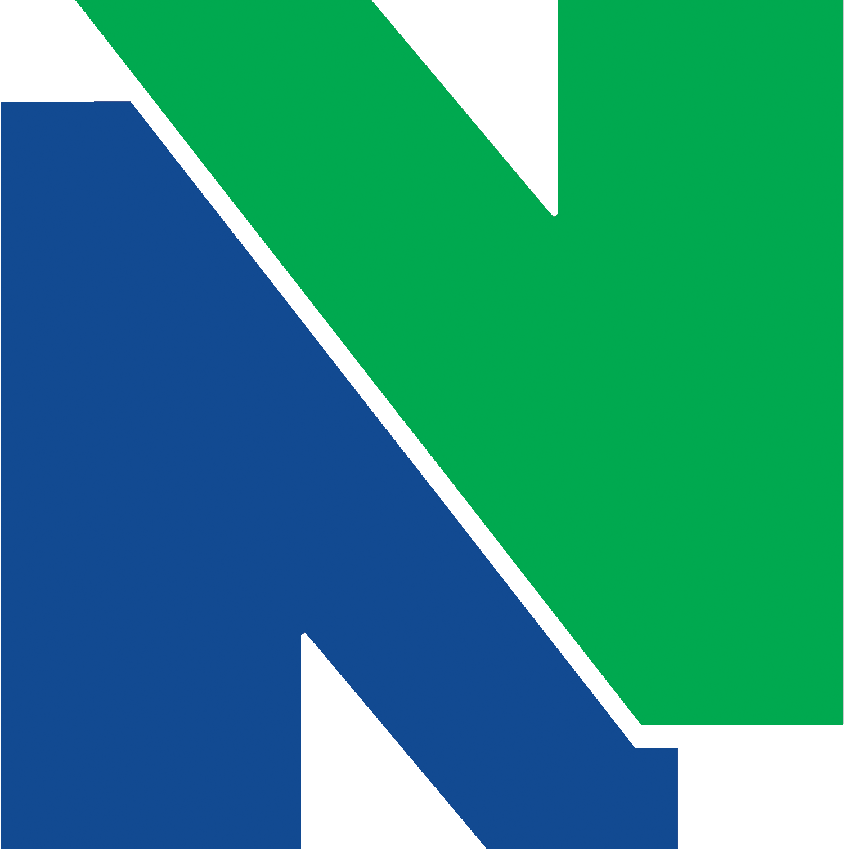
NEASC NEWS

October 17, 2011

Work is well underway for our Ten Year NEASC Self Study and we’re halfway to our NEASC visit! The 11 Standards committees have been busy since last Fall and will continue working through this academic year. Approximately 100 faculty and staff are members of these committees and have been putting in many hours working on our accreditation.

The work has been divided into three phases which correspond to the three sections of the self-study required by NEASC. Phase One, the Description, focused on describing what NVCC does in each of the 11 Standard areas outlined by NEASC. This phase of the work focused on initial data collection about what NVCC does to meet each of the Standards and culminated last spring when the committees submitted their information to Patti Pallis, who is writing the report. Patti has completed all but one of the Description sections and those are being reviewed by each of the Standards committees, as well as the Steering Committee (President DeFilippis, Dean Palmer, Dean Troup, AJ Dubois and Kim O’Donnell).

Work this semester has focused on Appraisal, or an assessment of how well we meet the Standards laid out by NEASC. You will see another employee survey very soon, with a student survey distributed later this semester. You will also have another opportunity to provide input into our NEASC process in November when we hold Open Forums for the appraisal segment of this work. This is a time for everyone to review the self-study work and to provide feedback about accuracy and completeness. We’re hoping that all of you are able to participate.

Please look for weekly NEASC News emails throughout the academic year. We’ll highlight one or two of the 11 Standards each week.

Sincerely,

Dean Sandra Palmer & Kim O’Donnell
Your NEASC Co-chairs

