Max R. Traurig Library/Learning Resources Center

Annual Report 2014-15

# Accomplishments, Challenges, and Goals

This has been an exciting year for the Library, filled with accomplishments and challenges alike. Key accomplishments of the year include:

* Successful participation and completion of the Assessment in Action program
* Increased in library instruction sessions and embedded librarians
* Increased outreach to the Danbury Campus through instruction and collections
* Completion of the RFID security system project and corresponding technology upgrades
* Increased creation and utilization of 21st century learning supports such as Library Research Guides, quizzes, tutorials, and videos and successful integration into Blackboard
* Creation and facilitation of a One Book, One College program
* Expansion of and publicity for new fiction, particularly focused on diverse authors, and corresponding increase in book circulation
* 47% increase in overall traffic in the Library
* Upgrades in technology, access, and online services to students
* Expanded marketing to students, staff, faculty and the community

Despite the many accomplishments of this year, the Library faced some challenges:

* Many staffing changes, particularly in Circulation
* Ongoing difficulty obtaining textbook information from the bookstore
* Increasing costs of databases coupled with a budget reduction in the spring of 2015
* Need for defined quiet study areas
* A rapidly changing information landscape which created a barrier for successful deployment of open educational resources as a replacement of textbooks

Goals for 2015-16 will center on the following themes, and corresponding activities:

* Expanding Outreach in Danbury
  + Develop recommendations for new space
  + Deploy and assess
* Stabilize and Streamline Staffing Structure
  + Replace vacant Library Associate position
  + Evaluate EA versus SA assignment of duties
  + Enhance and expand the orientation and training program for frontline staff to ensure consistent standards of service
* Highlighting the Collection Beyond Assignments
  + Increase drop-in workshop offerings
  + Offer lifelong learning/personal enrichment programs such as the Human Library
  + Host traveling exhibits, speakers, and other programs of wide interest
  + Identify components of the Framework for Information Literacy that can be introduced to first semester students and to classes with a research component
* Deploy Recommendations from Assessment in Action
  + Engage high schools in collaboration
  + Offer personal librarians to non-traditional aged first time students
  + Introduce qualitative assessment of library instruction
  + Refine FYE program
* Lynda Project: Helping Students Gain Technological Access and Literacy
  + Offer Blackboard workshops for students
  + Offer Lynda.com access to students, staff, and faculty
  + Circulate laptops and Wi-Fi hotspots to students
* Maximizing Use of Library Space
  + Create more student study spaces in areas previously used for storage
  + Increase collection displays to create a “library” atmosphere in L523
  + Promote room booking service
  + Monitor and maintain space for noise and cleanliness

## Information Literacy

Major changes took place regarding information literacy in 2014-15. The most significant change was Association of College and Research Libraries (ACRL)’s adoption of the new *Framework for Information Literacy for Higher Education*[1], which will eventually replace the *Standards for Information Literacy*[2]that was published in 2000.

The *Framework* is comprised of 6 concepts, each of which is illustrated with knowledge practices and dispositions. The 6 concepts are:

1. Authority Is Constructed and Contextual
2. Information Creation as a Process
3. Information Has Value
4. Research as Inquiry
5. Scholarship as Conversation
6. Searching as Strategic Exploration

The *Framework* concepts were introduced into the information literacy sessions taught to First Year Experience students, and students were assessed on their understanding of those concepts. More information about this project can be found in the Assessment in Action summary (below).

**Assessment in Action**

In 2014-15, the Library applied for and was accepted into a national assessment program sponsored by ACRL and the Institute of Library and Museum Studies (IMLS). As part of this program, the librarians established a research project and conducted assessment. In addition, the Director traveled to national conferences to participate in several days of assessment training. The project was ultimately presented at a poster session at a national conference in June of 2015.

The project required all first-year, full-time students enrolled in FYE to take a needs assessment of information literacy skills, and then to attend one class session at the library, taught by one of the Reference & Instruction Librarians. Then, students took an i>clicker quiz to test library skills learned at the conclusion of the class session. Pre- and post-test scores were linked with a student ID number, and the scores were then matched up with student data supplied by the IR Office. This data included student characteristics such as age, gender, GPA and retention status, and high school.

As part of the Assessment in Action project, the assessment questions were mapped to the draft of ACRL’s *Framework for Information Literacy*. Students were asked to give their ID numbers when taking the needs assessment and again in class, so that their responses could be matched and tied to demographic data. The 563 successfully matched students who took both assessments were grouped into four cohorts:

Cohort 1: Scored high on both assessments

Cohort 2: Scored high on A1 and low on A2

Cohort 3: Scored low on A1 and high on A2

Cohort 4: Scored low on both assessments

The results of the Assessment in Action project show that 563 students took both the pre- and post-test, and 68% of students improved their score, with an average increase of 19.22 percentage points. Furthermore, by dividing the students into four “cohorts” based on scoring patterns, we were able to determine areas of need among several student populations. For example, 225 students, or 39.96 percent, scored high on both assessments. Additionally, 84 students or 14.92% scored low on both assessments. By closely examining these cohorts, we were able to identify student characteristics that can help us take a targeted approach to future outreach and instruction efforts, including increased support for older students and collaboration with urban public high schools. The study also demonstrated that a pre-existing knowledge of information literacy concepts contributed to student success and retention.

As a result of these findings, the librarians plan to

* engage with librarians and teachers from the low performing high schools in order to find ways to increase student information literacy prior to coming to college.
* offer “personal librarians” to older students to better support their learning
* introduce qualitative assessment in FYE classes to continue ongoing improvement
* refine questions and activities in the sessions to reduce “library lingo” and keep students engaged

**Library Instruction**

Library instruction sessions increased in 2014-15, despite the number of FYE sections declining over the prior year. Non-FYE sessions increased from 78 to 94, and the total number of sessions increased from 127 to 138 over 2013-14. Each semester, 8 sessions were taught in Danbury by two of the reference librarians.

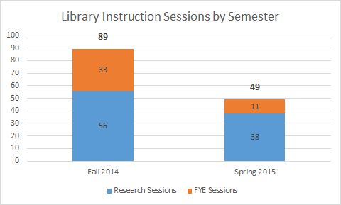

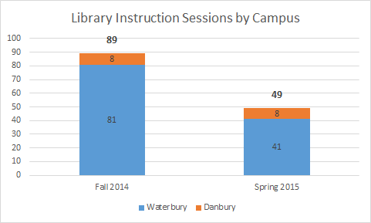

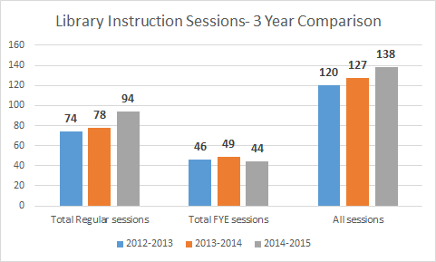

Other innovations in instruction took place in 2014-15. A third assessment was added to FYE in order to measure retention of student learning at the end of the semester. Though the number of respondents was not high, the percentage of students who maintained a high score was approximately 90%. A pilot project for ENG 063 students, designed by Liz Frechette with English faculty Brian Goedde, engaged students in a hands on research activity designed to foster exploration of library resources and hands on learning. Librarians also offered research appointments to students taking Honors courses and created a library research guide for Honors students. A librarian will serve on the Honors committee in the upcoming academic year.

The reference librarians also expanded the embedded librarian program, which is designed as a partnership between faculty and librarians to provide ongoing support to a particular class. This program, as well as the other aspects of the librarian liaison program, were formalized in 2014-15 and an informational brochure was created for faculty outreach.

## 21st Century Library Technology

Library technology and student access were equally impacted by technology in 2014-15. The Circulation department added the RFID security system and receipt printers to their area. The RFID system, besides proving security for the library collection, enables students to borrow and renew items at kiosks, and provides a printed receipt of borrowed items.

Librarians created 26 library research guides, or LibGuides, over the year, ranging in topic from Gerontology to Graphic Novels- nearly twice as many as were created last year. The number of views per guide increased as well- the top ten guides in 2013-14 averaged 633 views, but in 2014-15 that number increased to 836.

***Top 10 LibGuides 2013-14 Views Top 10 LibGuides 2014-15 Views***

|  |  |  |  |
| --- | --- | --- | --- |
| ART H101 Art History 1 Resources | 901 | PSY H111 General Psychology I | 1359 |
| Library Facts for Faculty | 784 | Library Facts for Faculty | 890 |
| BIO H115 Human Biology | 782 | IDS H101 First Year Experience | 853 |
| Psychology | 730 | Psychology | 813 |
| Citation Guides | 610 | Great Web Resources | 806 |
| ENG H101 Composition | 587 | ESL H169 Reading and Writing VI | 784 |
| Great Web Resources | 568 | Library Policies | 776 |
| Library Policies | 554 | HSE H281 Human Services Field Work I | 735 |
| IDS H101 First Year Experience | 434 | Physical Therapy | 705 |
| Junot Diaz | 383 | ENG H101 Composition | 641 |

LibGuides were added to faculty course shells directly through Blackboard thanks to a collaboration between Alison Wang and Carrie Horvath, Director of Distance Learning. When students click on the Library menu item in their Blackboard shell, they are given a customized link to resources for their area of study.

The LibGuides system itself was upgraded to Version 2 in 2014-15. This upgrade required significant data cleanup before and after migration, as well as a redesign of the templates and other settings for the guides. The upgrade resulted in a more attractive and functional look.

Reference librarians also developed tutorials, quizzes, and videos that were added to LibGuides and posted to Youtube. Customized videos were created for both online classes and embedded in Blackboard. Students can now contact librarians for assistance via text message and by using chat boxes on the library homepage and within LibGuides. Study rooms and spaces can also be booked in advance using the library website.

Databases, ebooks, and streaming films were all made available to students on and off campus. Signing into the databases was streamlined by utilizing the proxy server rather than rerouting students to the Library tab in myCommNet.

Alison Wang chaired the acquisitions subcommittee for the system-wide search for a new Integrated Library System (ILS). A new system will be selected by July of 2015, with migration to start in January of 2016. The 4 Connecticut State Universities, Charter Oak State College, and the 12 Connecticut Community Colleges will all migrate to the new system by the end of 2016.

## Outreach to Students, Staff, Faculty, and the Community

The One Book, One College common reading program was held in the spring of 2015. Eleven lectures, discussions, and workshops were held throughout the semester and were attended by over 100 students and many faculty and staff. The book, *When the Emperor Was Divine*, was also read by FYE students and used in history, english, and even art classes. The project was so successful that a campus committee was created to expand the program into a year-long initiative for 2015-16.

New programming was introduced, namely the ExCITEing Snacks event and Citation Workshops, which attracted over 200 students. Snacks, made by library staff, were provided for free along with recipe cards that explained how to cite the source of the recipe. A corresponding LibGuide was also created.

Exam Cram, Open House, and New Student Orientations were events that allowed the Library to promote services and collections. New promotional materials were created including buttons, pencils, and handouts, and many new posters and digital signs were used throughout the year to advertise what the Library has to offer. Social media became a bigger part of library outreach this year, and student contests like the “NVCC Shelfie” photo competition were held. Exam Cram featured hot cocoa, the ever-popular Kodiak, a therapy dog, and yoga sessions for students.

The Library continued to publish the quarterly newsletter, newly renamed “Knowledge to the Max,” which was shared with faculty and staff via email and posted on the library website and library social media accounts for students.

In order to promote reading and lifelong learning, library staff created small book displays to highlight interesting topics such as fiction set in London, books on creativity, Psychothriller DVDs, and new ESL titles. More display areas were added on the 4th floor to further promote new titles. Bulletin boards and book carts were also used to highlight celebrations of diversity, holidays, and new items in areas of high interest. The Library Book Group met three times for lively discussion by faculty and staff hosted by Elaine Milnor. The Library also worked with Student Government to design and install a Book Nook for student reading in L501, the Library Oasis.

Community use of the library increased this year, likely due to the suspension of computer classes at the Silas Bronson Library in Waterbury and the increased ease of access to the college through public transportation. Community users borrowed 150 items this year, compared to 21 the previous year. IT resigned the system used to issue community guest computer accounts, which provided a way to better track printing and prevent excessive printing by non-students.

## Collection and Circulation

<insert information from Alison>

Prior to 2011, the collection started with Library of Congress call numbers A through ND on the Mezzanine and NE through Z on the 5th floor. When the library entrance was moved, this order no longer made sense. In the summer of 2014, circulation staff members Liza Zandonella and Julie Schumacher moved all 30,000 titles to swap the order of the collection. This project also provided an opportunity to shift the collection so that the books were evenly placed, as well as clean the actual shelves. This also provided the opportunity to remove some of the short shelves and add study carrels on the 5th floor for more quiet study space, a need that was identified in the 2013 Library Program Review.

The textbook collection continues to be one of the most popular, yet labor intensive, areas of the library collection. Textbooks were checked out nearly 7000 times this year, a decline from last year but still significantly higher than the year before. Non-textbook print circulation climbed this year to over 4000.

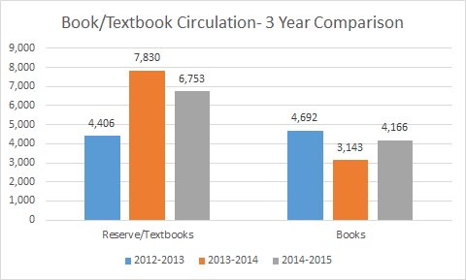

Circulation and Technical Services staff have continued to collaborate on streamlining the textbook acquisition process to ensure student access to course materials.

Student use of library materials dropped slightly from 2013-14, but circulation per 1000 FTE is nearly identical. Faculty and staff use increased this year, as did community member use.

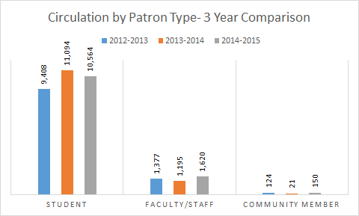

The number of textbooks made available to students at the Danbury campus continues to increase. Requests for other materials will need to be addressed in order to provide equitable library services to Danbury students in the next academic year.

Assignment of duties in the Circulation department continues to be a challenge due to staff departures. Interlibrary loan and serials have been reassigned several times as Circulation EAs have left NVCC for other positions. Turnover in work study students, while expected, creates an ongoing need for training. Ongoing increases in library hours, beginning with Sundays and Friday afternoons in the last few years and extending Wednesday and Thursday nights this year have increased the need for desk coverage by 12.5 hours, and eliminated time when staff was in but the library was closed- a time when “behind the scenes” tasks could be done. Stabilizing staffing will be a priority in 2015-16.

A large music donation was received at the end of the academic year, including nonfiction, scores, and CDs. Jenna Barry and Andrew Ardizzoia, instructor of music, collaborated on reviewing the donation.

The fiction collection was expanded this year as a result of an increase in the library’s budget in 2014-15. Diverse voices were the focus of the expansion, but many classics were added as well. Fiction circulation increased by 12% over the previous year.

## Space and Use

Due to the new security gate system, which monitors traffic through both entrances to the Library, Library use statistics became more reliable and easier to disaggregate. Traffic in the Library increased by 47% in the spring of 2015, compared to spring of 2014, when the gates were installed. September was the busiest month of the fall semester, while April was the most active month in the spring.

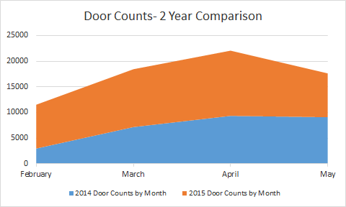

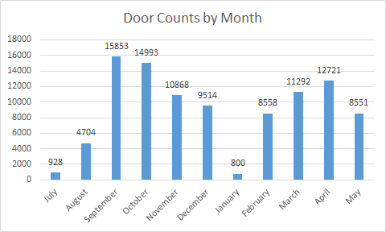

Cleaning and food in the Library were ongoing issues, but were addressed in 2014-15 through collaboration with maintenance staff and a renewed food policy and corresponding signs. A new eating area is being created outside of the 4th floor entrance to provide a space for students to eat and keep the Library clean and inviting.

The addition of the new study carrels in the 5th floor stacks provided more much needed quiet study space for students. Students also utilized the text service to request staff assistance when students were not respecting the policy of quiet in designated areas.

## Staff Development and Accomplishments

The Library staff attended national, state, and local conferences, participated in online webinars and training, and read articles for discussion at staff meetings in order to further education and mastery of skills. Those who attended conferences recapped highlights at biweekly staff meetings and recommended innovative practices for implementation. In addition, the Library was represented in college advisory committees, promotion, tenure, and search committees, and supported many other college initiatives throughout the year.

The staff also continued to support the START sessions for new students by giving presentations, and the Library (including L501) was used throughout the year for advising and as a registration lab.

## Library Facts

**Library Hours**

Regular semester hours open: 64.5- ***Extended in 2014-15 by 4 hours***

Summer hours open: 48.5

***Fall/Spring Semesters Summer Hours***

Monday to Thursday 8:00 am to 8:00 pm Monday to Thursday 8:00 am to 6:00 pm

Friday 8:00 am to 4:30 pm Friday 8:00 am to 4:30 pm

Saturday & Sunday 10:00 am to 2:00 pm Saturday & Sunday Closed

**Library Staff**

***Full Time***

Jenna Barry, Librarian (hired January 2015)

Elizabeth Frechette, Librarian

Jaime Hammond, Director of Library Services

John Leonetti, Librarian

Elaine Milnor, Library Associate

Alison Wang, Librarian

***Part Time***

Tiara Arnold, Librarian

Fedia Boiteux, Circulation Assistant (hired March 2015)

Allyssa Bruce, Circulation Assistant (resigned January 2015)

Gretchen Gallagher, Technical Services Assistant (resigned June 2015)

Jeffrey Kinnard, Circulation Assistant (hired February 2015)

Julie Schumacher, Circulation Assistant (resigned February 2015)

Naomi Toftness, Librarian (fall 2014 only)

Michelle Victory, Circulation Assistant

Liza Zandonella, Circulation Assistant

James Zanone, Technical Services Assistant

**Library Budget**

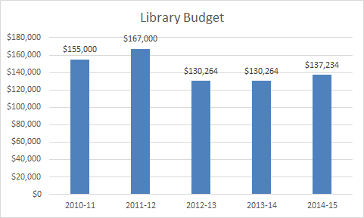

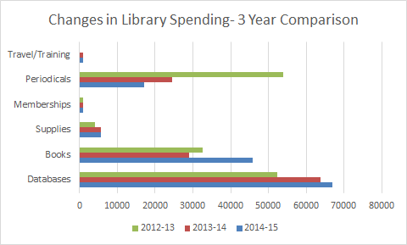

1. <http://www.ala.org/acrl/standards/ilframework>
2. <http://www.ala.org/acrl/standards/informationliteracycompetency>