**84** *Liberal Arts and Behavioral/Social Sciences Division*

# cropped-nasac_logo_color1.pngDRUG AND ALCOHOL RECOVERY COUNSELOR (DARC)

The Drug and Alcohol Recovery Counselor (DARC) program is nationally accredited through the National Addiction Studies Accreditation Commission (NASAC) and provides education and training for persons who want to become a Certified Addiction Counselor (CAC). The DARC curriculum (30 credits) meets the Connecticut Certification Board (CCB) requirements (300 hours of education, 300 hours of supervised practicum) to become a CAC. The DARC program is currently the only nationally accredited “Addiction Studies” program among all two and four year colleges in Connecticut.

## Employment

Students with a DARC Degree are highly sought after for entry level opportunities as substance abuse counselors in public and private agencies such as community and residential health facilities, local hospitals, prevention organizations, youth service agencies, and criminal justice system. According to the Occupational Outlook Handbook (2016-17 Ed.), employment of addiction counselors is expected to grow by 22 percent from 2014-2024, much faster than average as addiction counseling services are increasingly covered by insurance. Connecticut is considered one of the states with the highest concentration of jobs in this field with a mean average wage of $46, 920.

## Curriculum

The DARC program consists of two years of academic study which includes general education, DARC specialty courses and a one year internship. All DARC courses (DAR\*H101, H111, H112, H158, H213, H220) are open to any student at the college, provided they meet the prerequisite of ENG\*H096 or tested into ENG H101. Students should take DAR H101 and DAR H111 in fall, DAR H112 and DAR H158 in spring. (This would be switched if a student is attending evening classes.) Students have to complete this sequence to apply for the DARC Internship, which runs fall/spring of the next academic year. Students can be enrolled in the spring DAR courses and complete the Internship application/ interview process.

## DARC Internship Admission Process

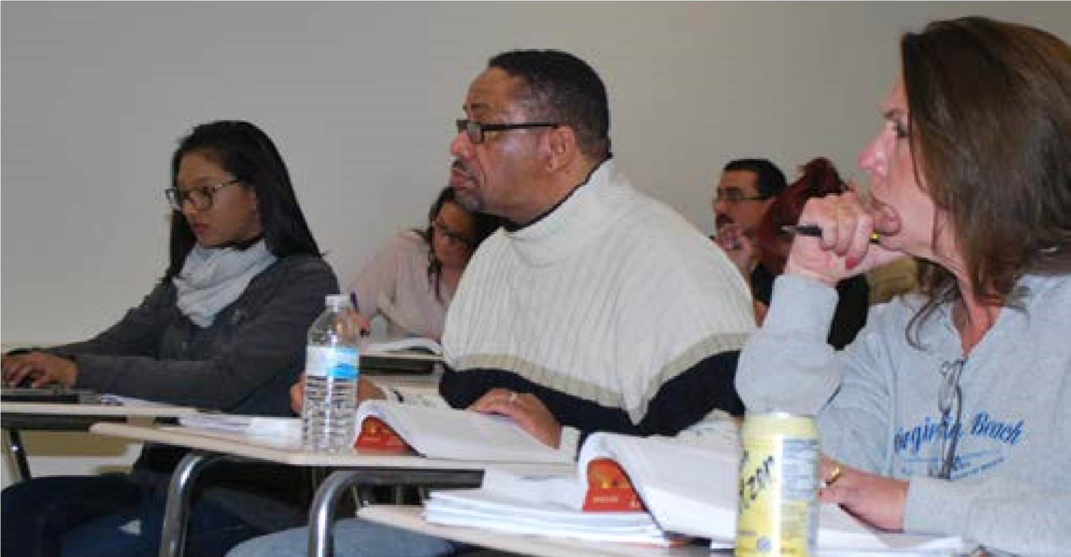Acceptance into the DARC Internship (DAR H251, DAR H252) is selective and not guaranteed. All students participate in a screening and interview process (spring semester) which is intended to evaluate whether the applicant possesses specific skills, behaviors and attitudes that are necessary to work with persons with addiction and co-occurring disorders. Interested applicants must have completed or be enrolled in DAR H101, H111, H112, H158 and ENG H101, and pass with a C or better prior to their internship. Students must complete and submit a formal DARC Application prior to the interview. Applications are distributed during the spring semester (Feb/March) each year. After the interviews, students are formally notified regarding acceptance to internship and ability to register for DAR H251-Counseling Internship I for the fall semester.

*General Education Core course listings and definitions appear on pages 53-54. Additional courses may be required. The suggested sequence for full-time students is shown on the following page. Note: The DARC program is highly sequenced. Students are encouraged to take courses in the order they are listed on the following page.*

# 85

*Liberal Arts and Behavioral/Social Sciences Division*

## DRUG AND ALCOHOL RECOVERY COUNSELOR (DARC)

|  |  |  |
| --- | --- | --- |
| **Competency or Program Requirement** | **Course Number and Title** | Required Credits |
| **FIRST SEMESTER** |  |  |
| Critical Analysis and Logical Thinking/  Written Communication | ENG\*H101 Composition | 3 |
| Oral Communication | COM\*H100 Introduction to Communication | 3 |
| Program Requirement | PSY\*H111 General Psychology I | 3 |
| Program Requirement | DAR\*H101 Public Health Issues in Abuse and Addiction | 3 |
| Program Requirement | DAR\*H111 Addiction Counseling I | 3 |
| **SECOND SEMESTER** |  |  |
| Scientific Reasoning◊◊ | DAR\*H158 Biology of Addiction | 3 |
| Social Phenomenon | SOC\*H101 Principles of Sociology | 3 |
| Written Communication | ENG\*H102 Literature and Composition | 3 |
| Program Requirement | PSY\*H245 Abnormal Psychology | 3 |
| Program Requirement | DAR\*H112 Group Counseling Theory & Techniques | 3 |
| **THIRD SEMESTER** |  |  |
| Continuing Learning and Information  Literacy/Ethics | CSA\*H105 Introduction to Computer Applications | 3 |
| Quantitative Reasoning◊ | MAT\*H135 Topics in Contemporary Mathematics† or MAT\*H167  Principles of Statistics1 | 3 |
| Scientific Knowledge◊◊ | BIO\*H115 Human Biology | 4 |
| Program Requirement | DAR\*H251 Counseling  Internship†† (fall only) | 6 |
| Program Requirement | DAR\*H220 Co-Occurring Disorders Counseling | 3 |
| **FOURTH SEMESTER** |  |  |
| Aesthetic Dimensions/Written Comm. | Choose any Aesthetic Dimensions listed | 3 |
| Historical Knowledge | Choose any Historical Knowledge listed HIS\*H101, 102, 201, 202 | 3 |
| Program Requirement | DAR\*H252 Counseling  Internship II2 (spring only) | 6 |
| Program Requirement | DAR\*H213 Addiction Counseling II | 3 |

### Total Credits: 64

*Any given course may only be used to satisfy one of the competency areas even if it is listed under more than one.*

1 Mathematics selection from MAT\*H135 for career degree students, or MAT\*H167 for students intending to transfer.

2 DAR\*H251 and DAR\*H252 must be completed in consecutive semesters.

◊ MAT\*H137 and courses numbered lower than MAT\*H137 will not transfer to Connecticut State Universities as Quantitative Reasoning courses. ◊◊ At least one Scientific Knowledge and Understanding OR Scientific Reasoning course must have a lab component.

#### Program Outcomes

*Upon successful completion of the DARC Program the graduate should be able to:*

1. Describe the physical, emotional and psychological basis of addiction
2. Define the causes and characteristics of substance dependence and addiction relevant to various populations and cultures
3. Define and apply counseling theories to addiction counseling including Adlerian, Existential, Person-Centered, Harm Reduction, Motivational Interviewing, Gestalt, Reality, Behavior, Cognitive Behavioral, Solution Focused, and Feminist perspectives
4. Define, demonstrate and apply ethical principles and practices according to NAADAC, the CCB, and professional behavior for working directly in the counseling field
5. Demonstrate knowledge and skills related to relapse prevention education and strategies
6. Describe the categories of drugs and effects on psychological functioning
7. Describe characteristics of individuals with co-occurring disorders and specific treatment strategies for working with this population
8. Demonstrate the ability to develop, write and implement treatment plans for individuals with addiction and co-occurring disorders
9. Co-facilitate group counseling sessions under supervision

***Associate***

***Degree***

***Programs***

1. Describe the use of case management in the treatment of persons with addiction and co-occurring disorders
2. Demonstrate ability to develop discharge plans for persons with addiction and co-occurring disorders
3. Demonstrate understanding of the screening, intake and evaluation process in addiction and co-occurring disorders treatment
4. Demonstrate ability to keep accurate records of group/ individual process, treatment and discharge planning
5. Describe and demonstrate skills involved in crisis intervention
6. Describe the purpose and availability of self-help groups for persons with addiction/co-occurring disorders
7. Describe the effects of substance abuse on the family, educational needs and stages of recovery for families
8. Describe the stages of change model and its application to treatment of addiction and co-occurring disorders
9. Describe the use of multicultural counseling skills to assessment, treatment and aftercare issues of persons of different gender, ethnicity, disability, adolescents, the elderly, GBLT and homeless
10. Describe the transdisciplinary foundations and competencies required of addiction counselor (TAP 21)
11. Describe the use of medication in the treatment of addiction and co-occurring disorders
12. Demonstrate engagement in community service activities to educate others about the process, dangers and treatment of addiction
13. Discuss the purpose of clinical supervision and participate in the supervision process
14. Write a comprehensive case study based on a biopsychosocial assessment, including diagnosis, treatment plan goals and interventions acceptable for submission to the Connecticut Certification Board (CCB).