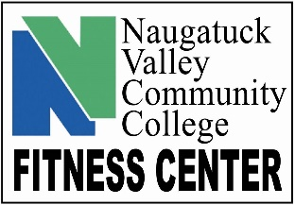
FITNESS CENTER RULES & REGULATIONS
Fall 2022

- You must scan your membership ID card every time you enter the facility.

- No tobacco, alcohol, drug or illegal substances are allowed in the facility.

- You are expected to act in a courteous and respectful manner. You are required to follow the instructions of the fitness staff at all times. Profanity, yelling rude or boisterous behavior will not be tolerated. There is no “hanging out”. There is no eating or drinking in the locker rooms.

- Clean, dry sneakers must be worn when working out. No street shoes, bare feet, sandals or cleats may be worn.

- Proper athletic clothing must be work when working out. Shirt and shoes must be worn at all times. Jeans, jean shorts, khakis and excessively loose fitting clothing are not allowed. Apparel with zippers, chains, rivets or buckles are not permitted. The Fitness Center reserves the right to determine what appropriate attire is.

- No bags, backpacks or personal items of any kind are allowed on the floor of the facility. Daily use lockers are available. You must provide your own lock and remove it at the end of the day. There are also coat hooks available in each locker room if you desire to use these. Showers are available for use. Please bring your own towel and shower supplies. The Fitness Center is not responsible for lost or stolen items. Items left in lockers over night will be discarded. Locks left on lockers overnight will be removed and all items in the locker will also be discarded.

- The Fitness Center will determine the music selection on the audio system and the television program on the TV. Personal music apparatus with headphones are allowed. Bluetooth speakers are not allowed.

- Food is not allowed in the facility. Spill proof, non-glass drink containers are allowed.

- Please wipe down equipment after each use.

- There is a 30-minute time limit on all cardiovascular machines when the room is determined crowded.

- No equipment is to be moved from its designated area. When using mats, bands, free weights, medicine balls and the like, you may use any open space that is available that does not interfere with other members working out.

- It is the member’s responsibility to follow ALL posted rules. Please see the staff member on duty if you have questions or need assistance.

- Youth under the age of 18 are not permitted in the fitness room. No member is allowed to bring guests.

Use of the Fitness Center is a privilege. Individuals who do not comply with the established policies will be asked to leave and may have their membership privileges revoked.

